Git init

git add .

git commit

git status

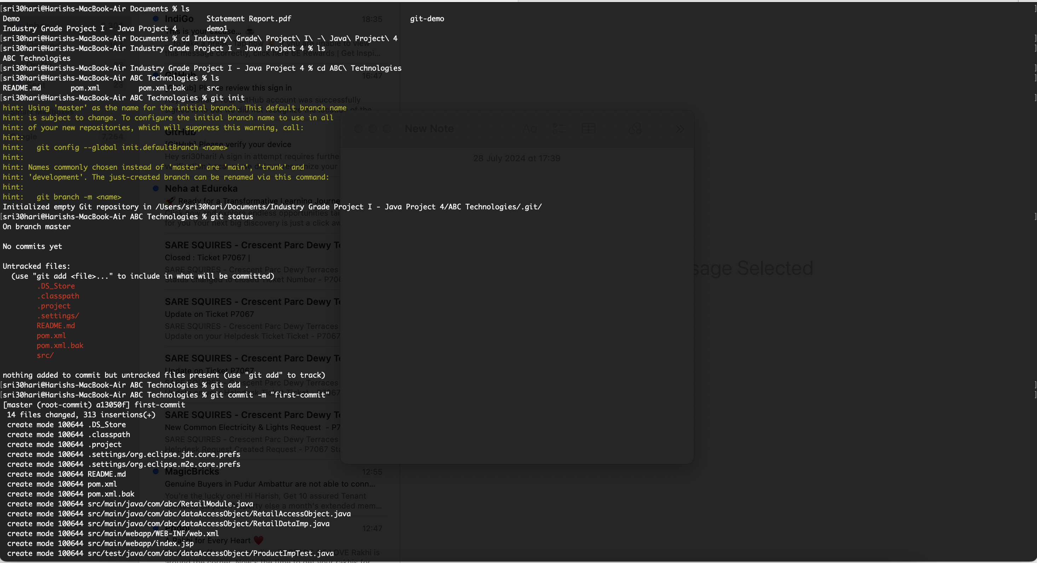

git push origin master

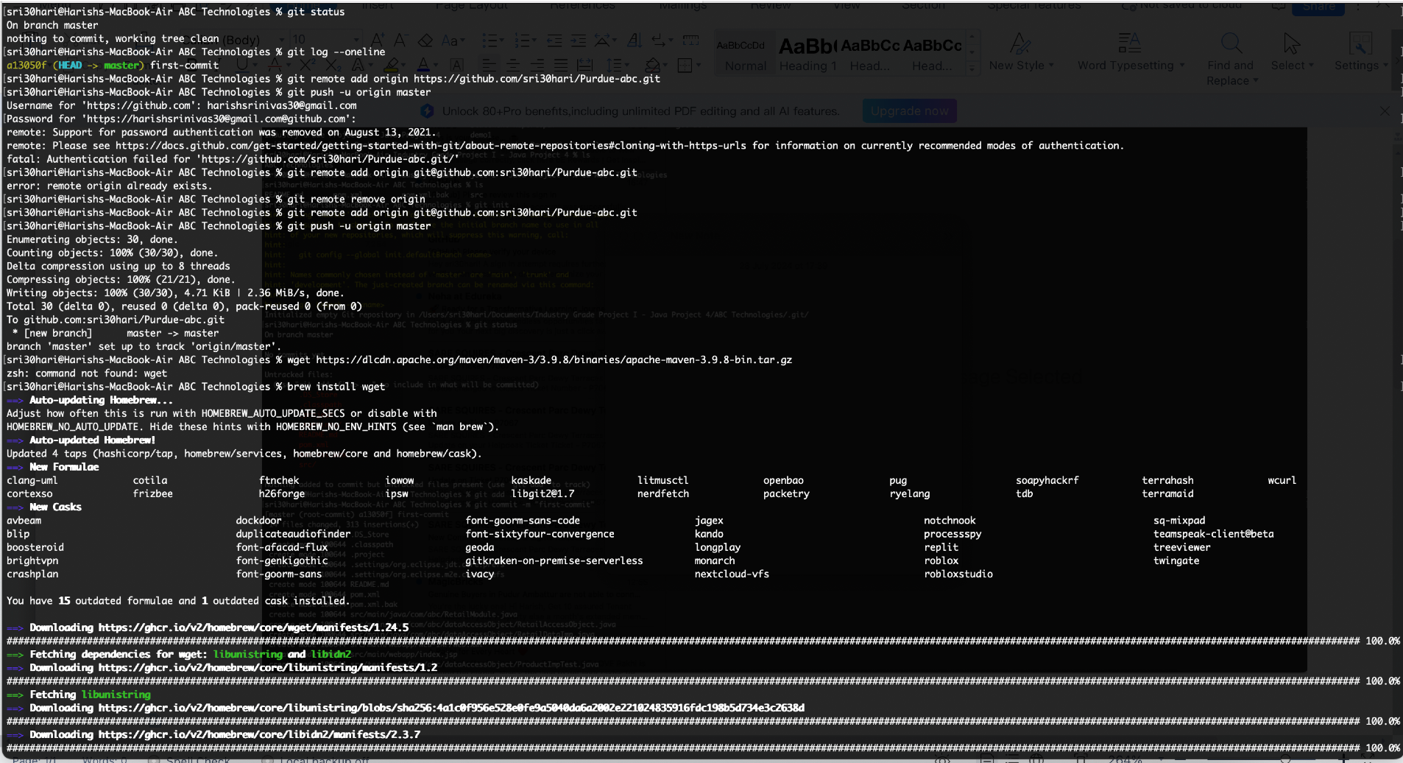

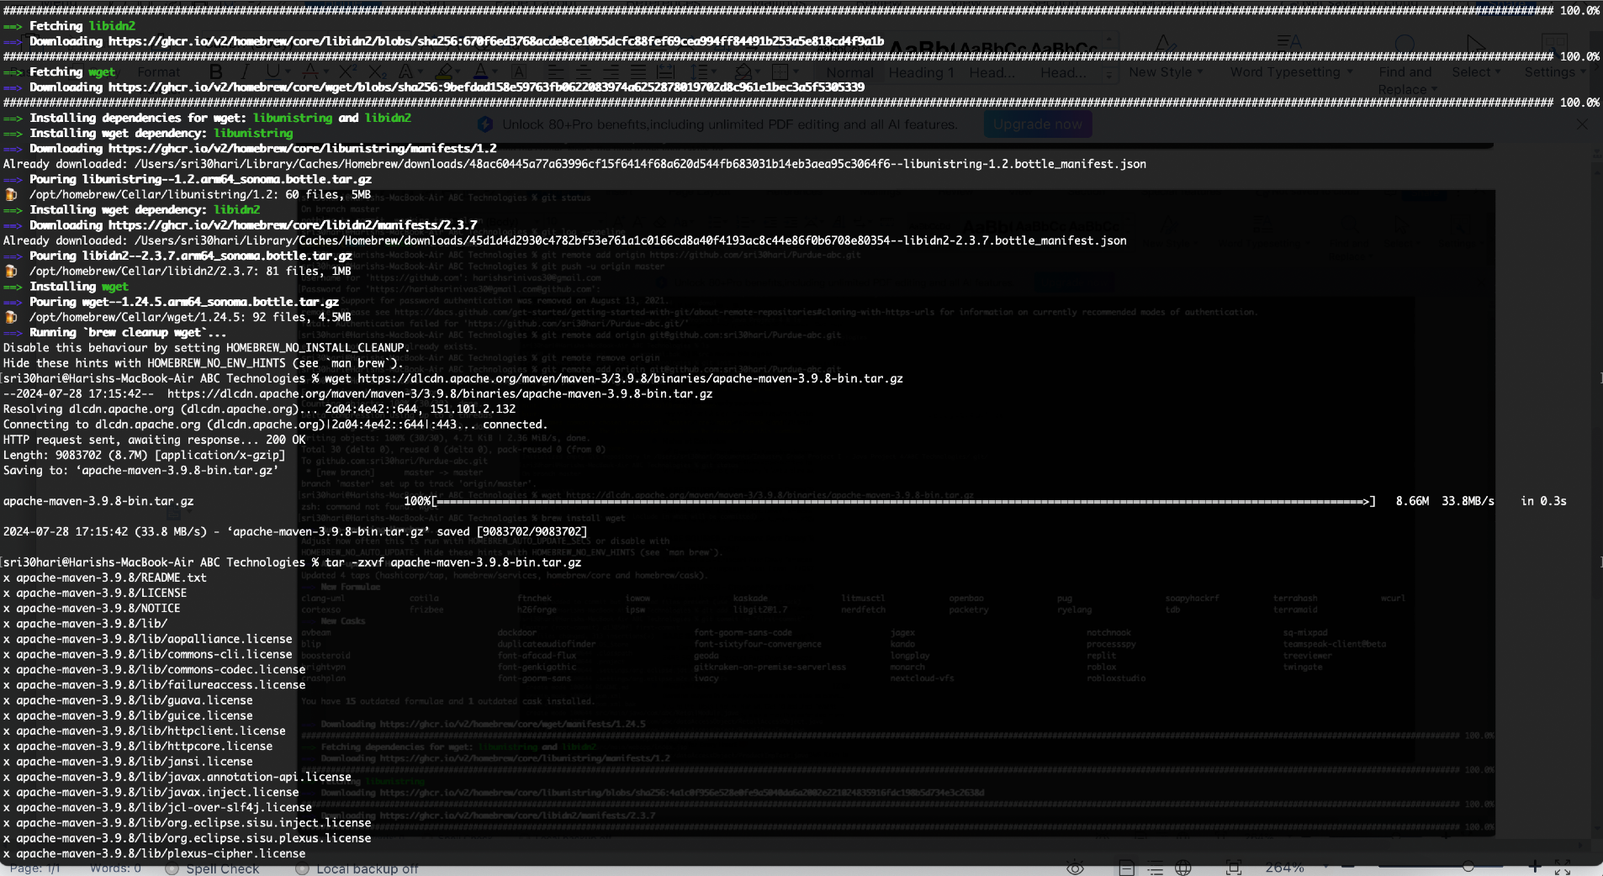

installed maven

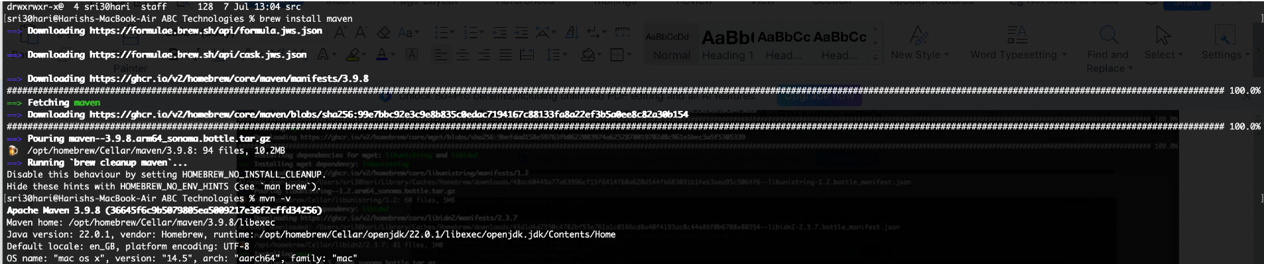

Git pull the repository file

mvn compile

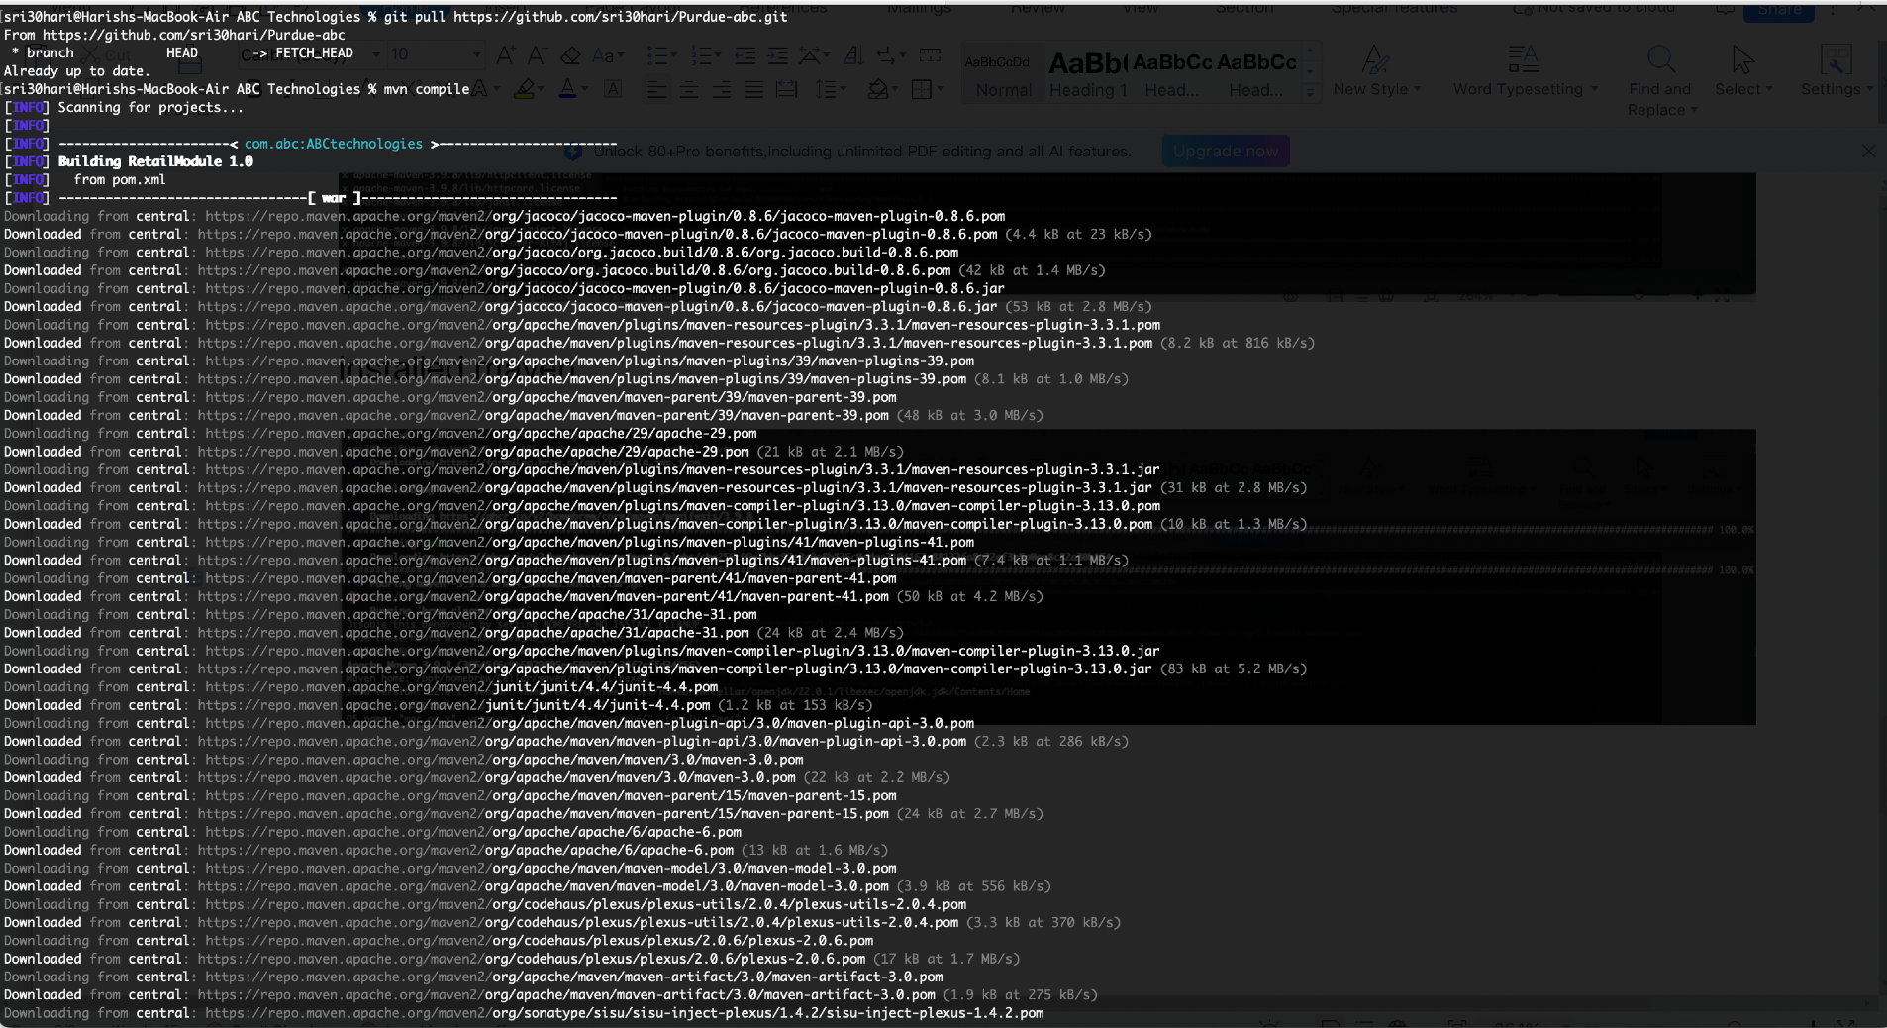

compile run success below snap with mvn test output

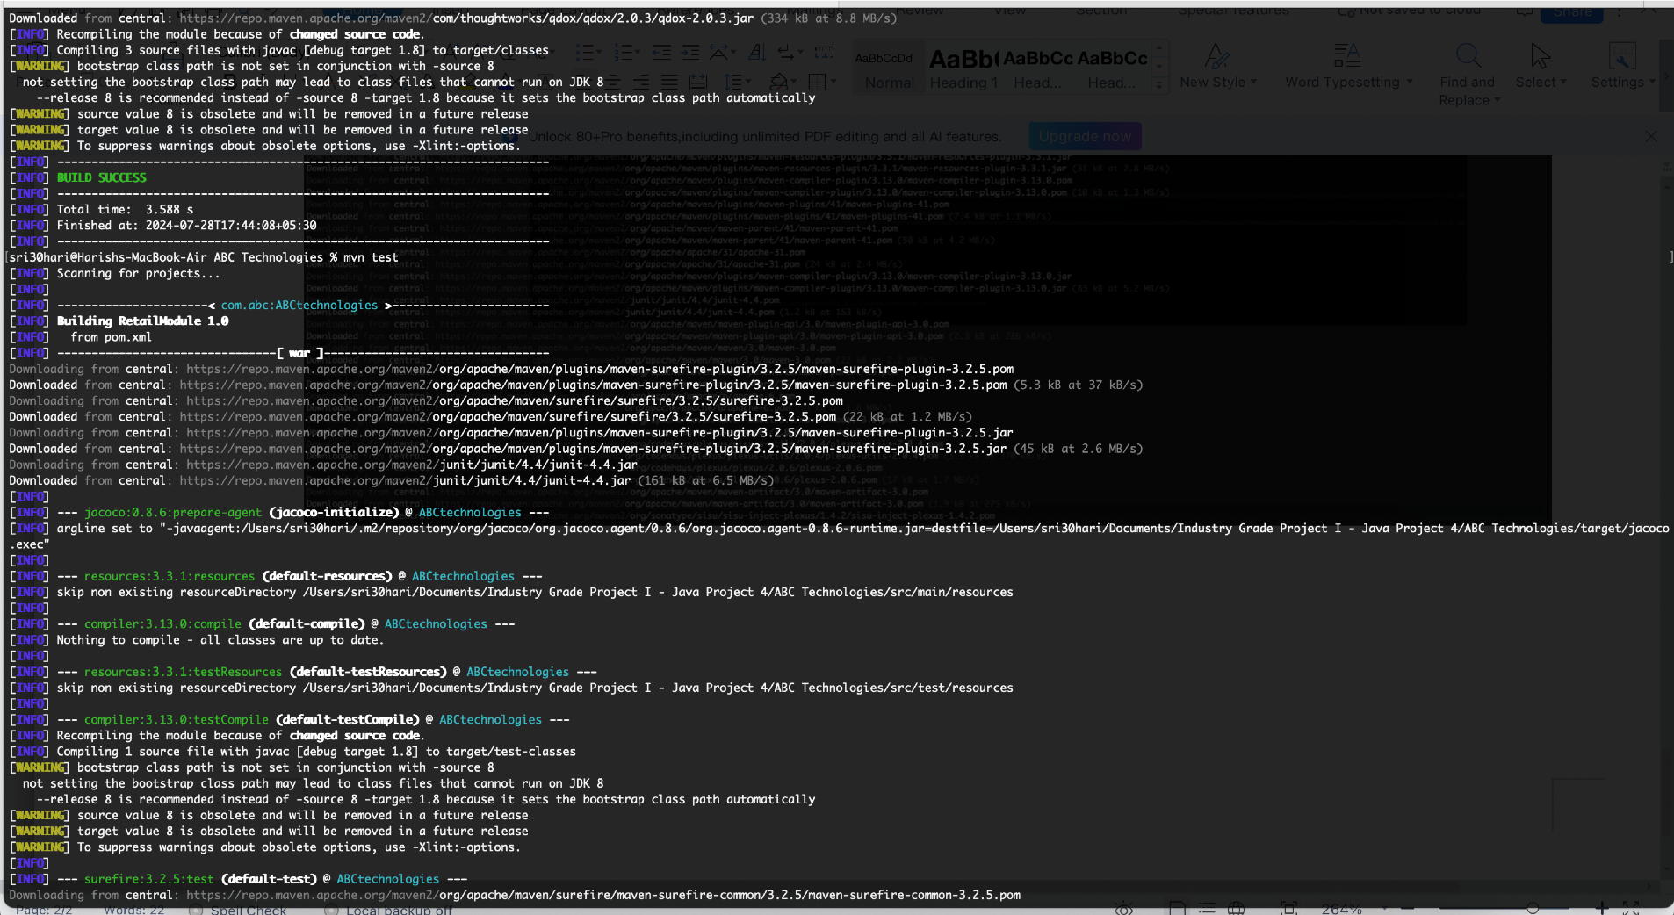

mvn test - build success

mvn package

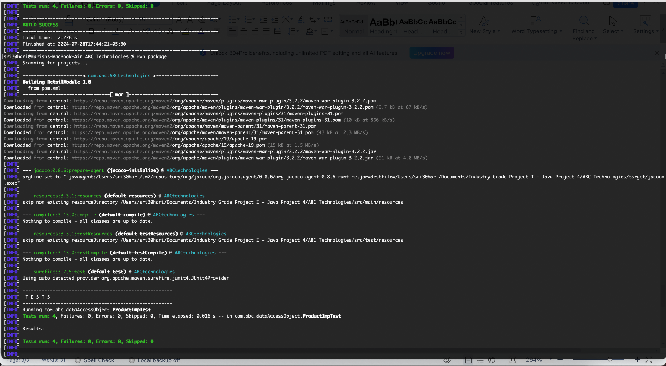

mvn package - build success

and installed docker

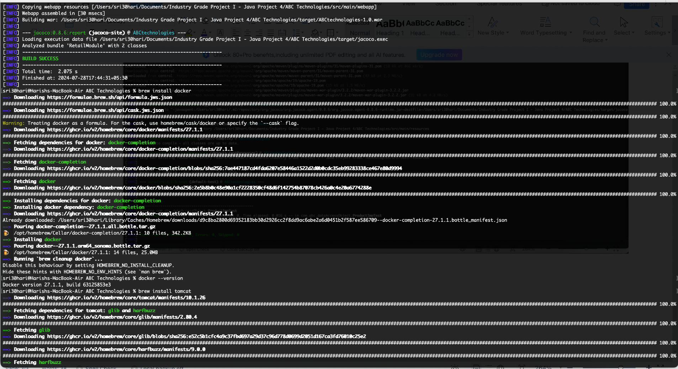

tomcat service start

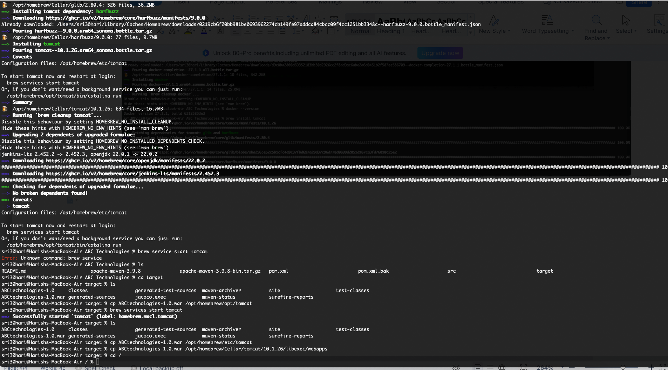

catalina run snap below

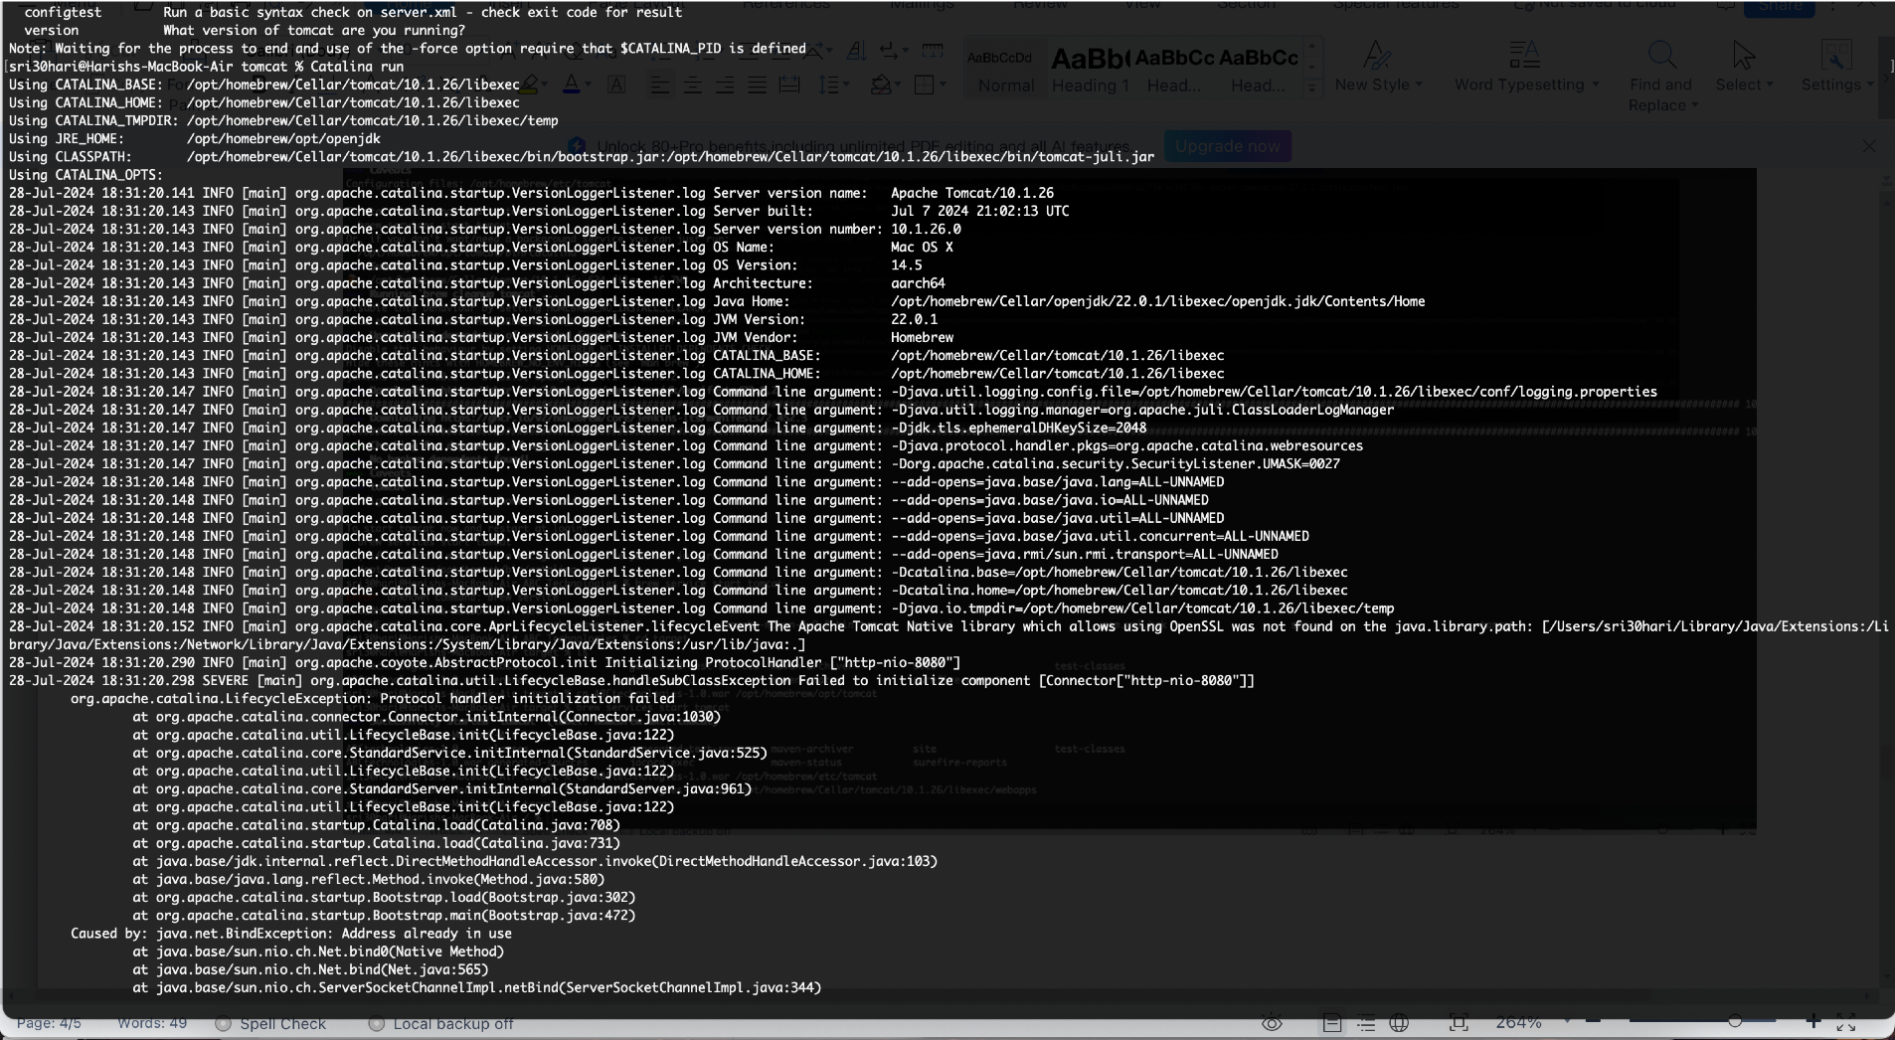

tomcat webapps folder path

opt/homebrew/Cellar/tomcat/10.1.26/libexec/webapps

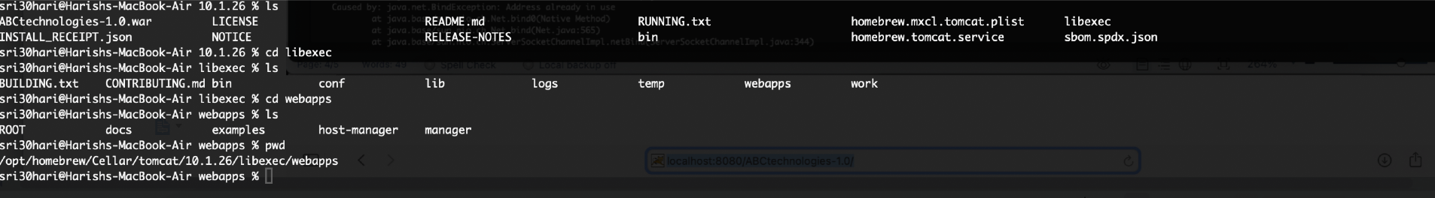

final output of tomcat web app

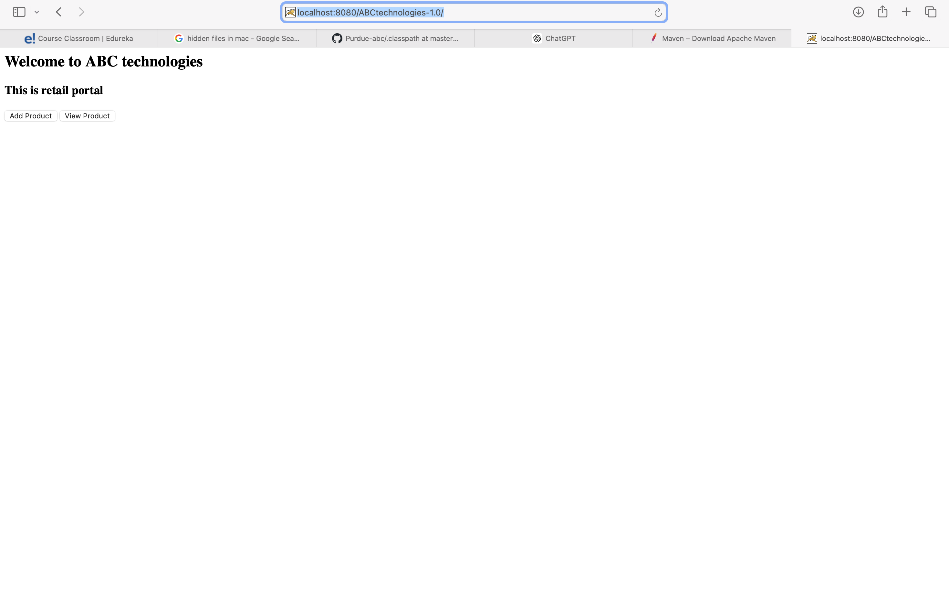

created docker file txt

added to git and pushed to origin

